user guide

1. Config SQL connection.cfg in eproject:

step 1: Open connection.cfg file in folder project

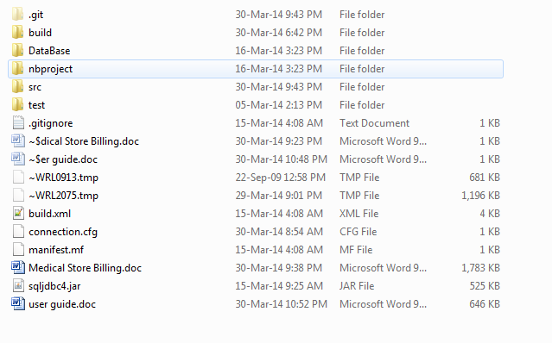

step 2 :

Change database, host, username, password for suitable with your SQL Server
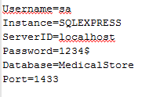

step 3 :

Select file MSBDB.sql
from eProject\eProject\database\ MSBDB.sql
Open with SQL server 2008 --> Execute

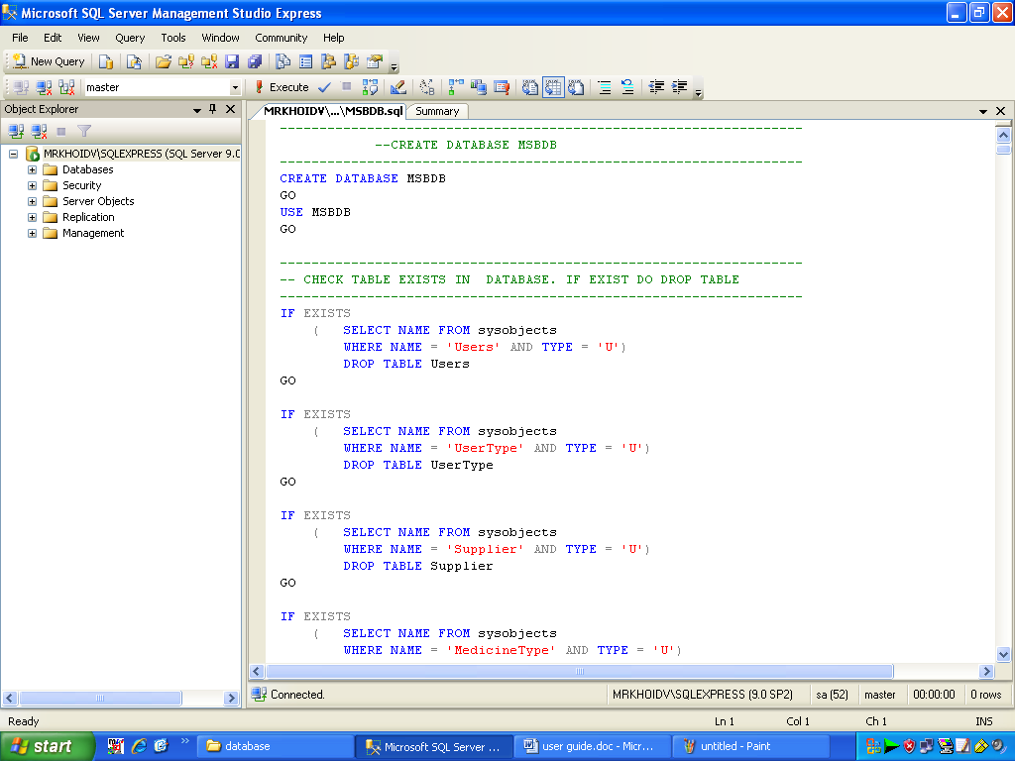

2. System mange guide

step 1:
Add JAR/Folder in to Library
from eProject\eProject\MedicalStoreBilling\library

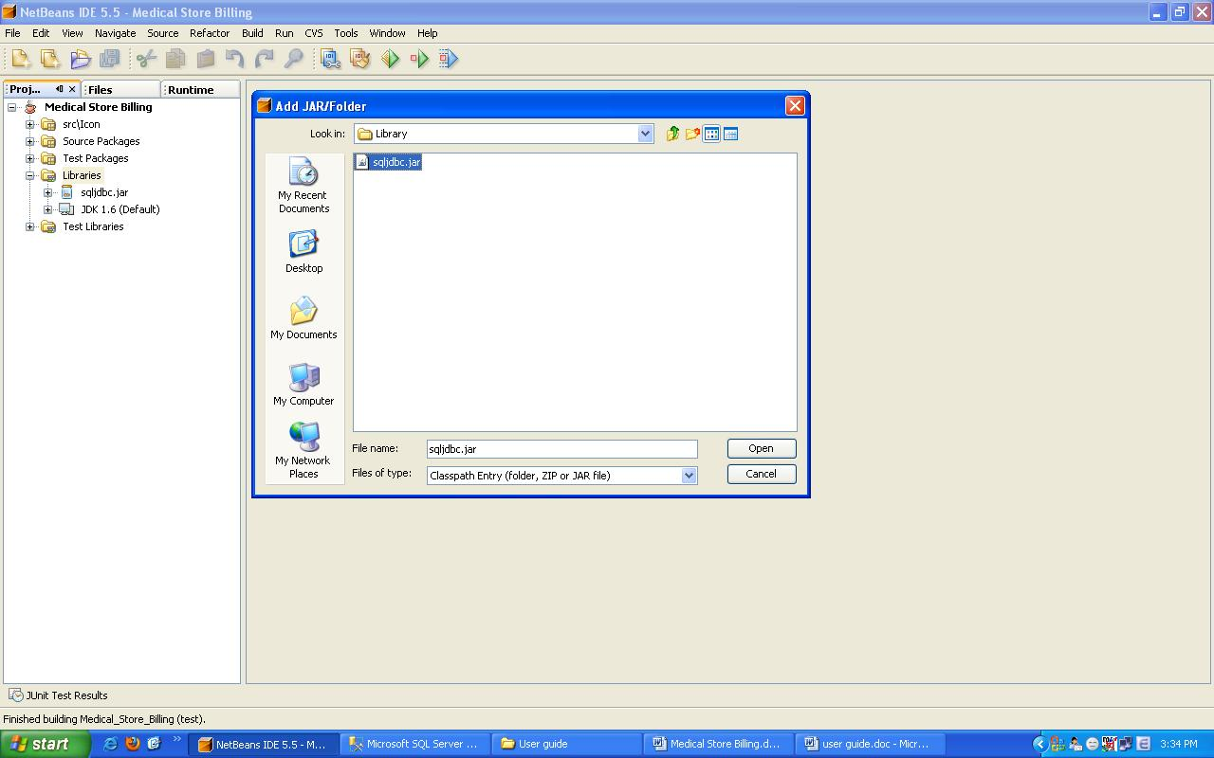

step 2 :
Run project

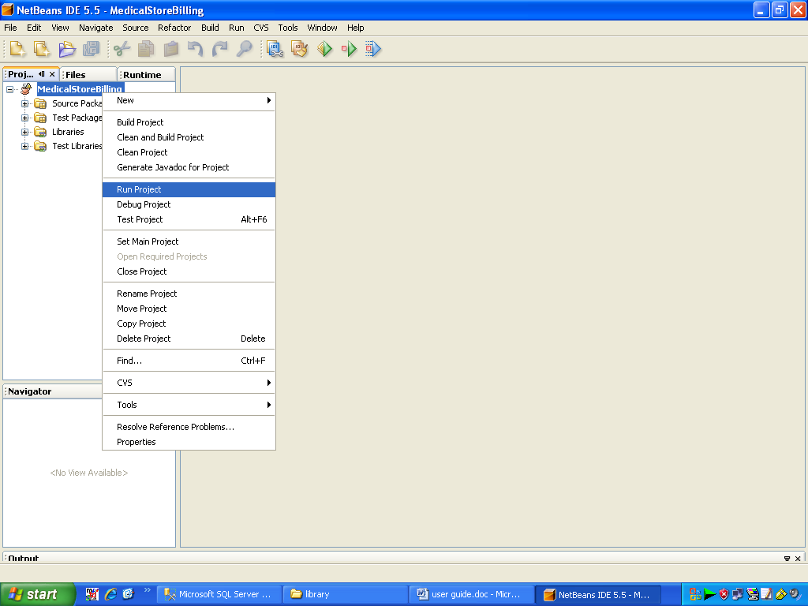

step3 :
Note: Software run well on resulation 1280x800
Login to MedicalStoreBilling

User Name : huynt57
Password : 123456789

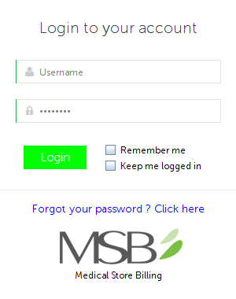

step 4 : System main

